Welcome to WMHA!

As you are aware, this season MMHA and WMHA have entered a Player Share Agreement for the 2025-2026 Season.
We have put together this document to help guide you through completing the TeamSnap WMHA Registration so we can get all of our players for the upcoming season together on one system. It is important to get your player registered as soon as possible to assist with planning for the upcoming season schedules such as projected registration numbers, tryout planning, ice schedules and team creation.

Please feel free to contact Chantelle (WMHA Registrar) by email at registrar20.wmha@gmail.com if you have any questions. WMHA TeamSnap registration platform will be used for the upcoming season for teams and communication with all members.

AEASE DO NOT PAY ANY FEES to WMHA. PLEASE PAY YOUR FEES TO MILLET MINOR HOCKEY AND THEY WILL TRANSFER FUNDS ON YOUR BEHALF

Millet Players REGISTER HERE or from the link on our website registration page HERE.

Fill out the registration form. To complete this you will need your players HCR number (if you need help locating this please contact Jacinthe, Chantelle or access your Spordle Account https://myaccount.spordle.com/dashboard)

When you get to the screen below, please enter MILLET2025 as your discount code. This will “exempt” you from the $200 volunteer deposit fee/WMHA raffle.

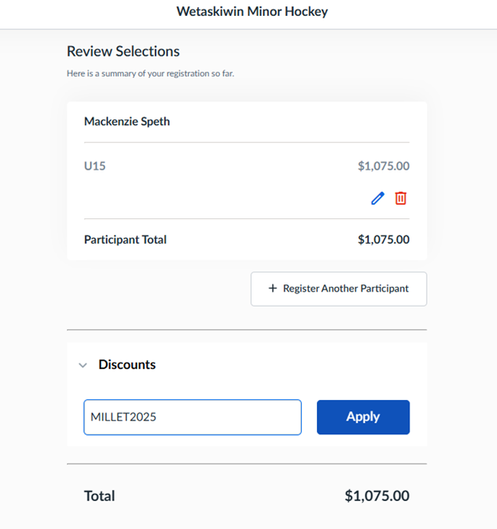

Once you hit Apply you should see a $200 discount as shown below
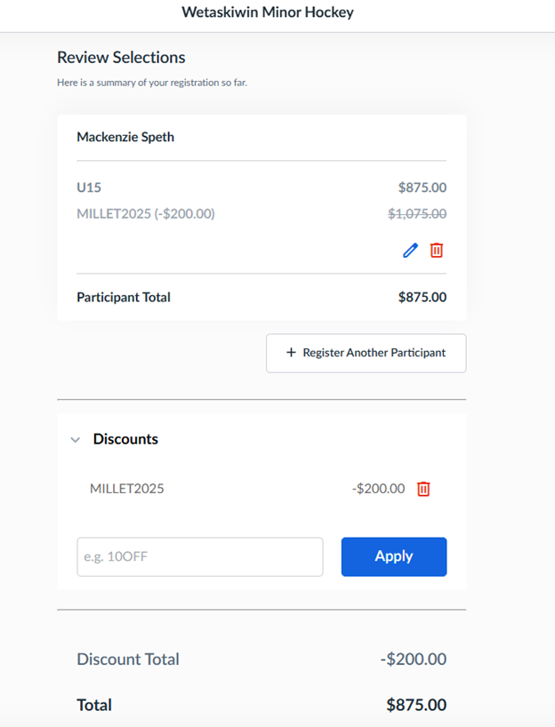

On the Check Out - Payment Plan page choose “More Payment Options”
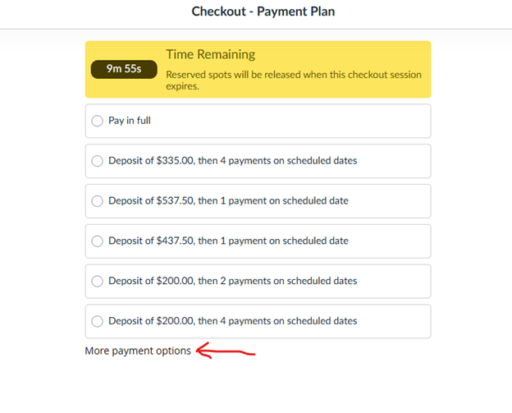
Choose “Continue to pay via cashP
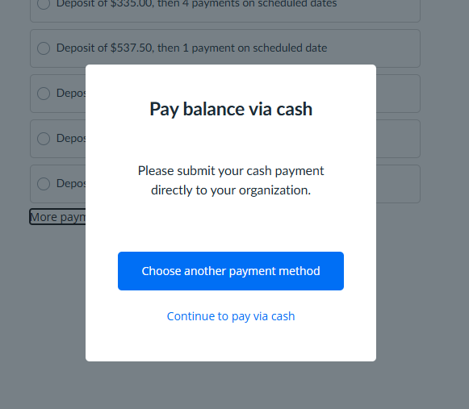
You should now get a successful registration message and an email will be sent to the address you used to register with more information.

PLEASE DO NOT PAY THE AMOUNT SHOWED OWNING. YOU WILL PAY YOUR FEES TO MILLET MINOR HOCKEY.

